Hw4 report

1. Cycle time:9ns

Recursive

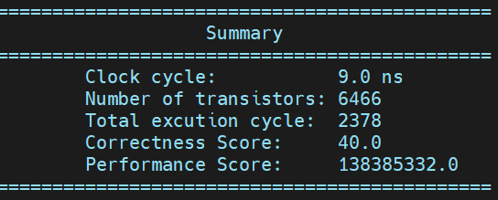

1. (c)Circuit Diagram

The whole module factor has three main parts, which handle the power of two, three, and five respectively.

I first use three LUT for each output, however, it will make the area become very large.